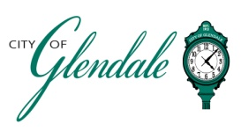
NOTICE OF PUBLIC MEETING
WEDNESDAY, AUGUST 5, 2026 – 6:00 P.M.
BOARD OF ADJUSTMENT MEETING
AGENDA

MEETING CALLED TO ORDER

ROLL CALL

APPROVAL OF MINUTES: MAY 6, 2026
- REQUEST FOR VARIANCE FOR 937 BROWNELL AVENUE

- MISCELLANEOUS

- ADJOURNMENT

